|  |  |  |  |
| --- | --- | --- | --- |
| **TITLE:** | Mirador Express System - User Manual | | |
| **sop #:** | IT-02 | **revision #:** | 1 |
| **EFFECTIVE DATE:** |  | | |
| **OWNER:** | Ravinder Saini | | |

## REVIEWERS

|  |  |  |  |
| --- | --- | --- | --- |
| Name | tITLE | sIGNATURE | dATE |
| Tamalur Shaikh | Int .NET Enterprise Web Portal Developer |  |  |
| Martin Schmidt | Sr. Analyst |  |  |

## APPROVER

|  |  |  |  |
| --- | --- | --- | --- |
| Name | tITLE | sIGNATURE | dATE |
| Elhadj Diallo | Business Intelligence Developer and Analyst |  |  |

# 1.0 purpose

To provide instructions on the use of the Mirador Express System.

# 2.0 SCOPE

This procedure applies to activities performed on the Mirador Express System at the Laird Facility.

# 3.0 equipment

* Mirador sensors

# 4.0 definitions

|  |  |
| --- | --- |
| **Definition** | **Explanation** |
| **Mirador Sensor** | Temperature monitoring device to log temperature |

# 5.0 Responsibility

|  |  |
| --- | --- |
| **Responsibility** | **Activity** |
| **Quality** | * Ensure the proper and adequate implementation of this procedure * Responsible for the training of all pertinent employees and the maintenance of their training records. * Follow instruction of this SOP * Responsible to assign user access level consequent with the user’s task description. |

# 6.0 policy

## general

* + 1. Start the web browser installed on your computer. For best results, use Microsoft Internet Explorer v.5 or later. Make sure the support of cookies and JavaScript is enabled in your browser.
    2. Enter the address of ***Mirador™ Express*** server in your browser. If you are not sure about the address, contact our support desk.
    3. The login page of ***Mirador™ Express*** web site will open. You might want to create a desktop shortcut to this page, to use it later.
    4. Enter your username and password in Login dialog window (**1**). If you forget your password, click Forget password link.
    5. Click on Login >> button. The main interface will be displayed.
    6. 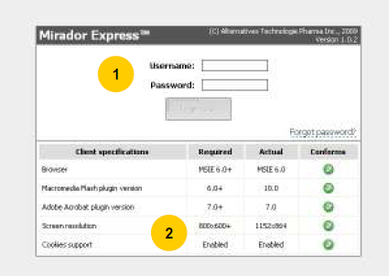The login page allows to verify if your client configuration is compliant with minimum requirements (**2**). If your browser does not meet all specifications, some or all features may be unavailable.

6.2 Main interface

* + 1. The main interface of ***Mirador™ Express*** consists of four sections:
       1. Main menu (**1**)
       2. Header section (company & site name, progress indicator, display mode buttons) (**2**)
       3. Display section (sites summary, floor plan or current values) (**3**)
       4. Alarms section (**4**)

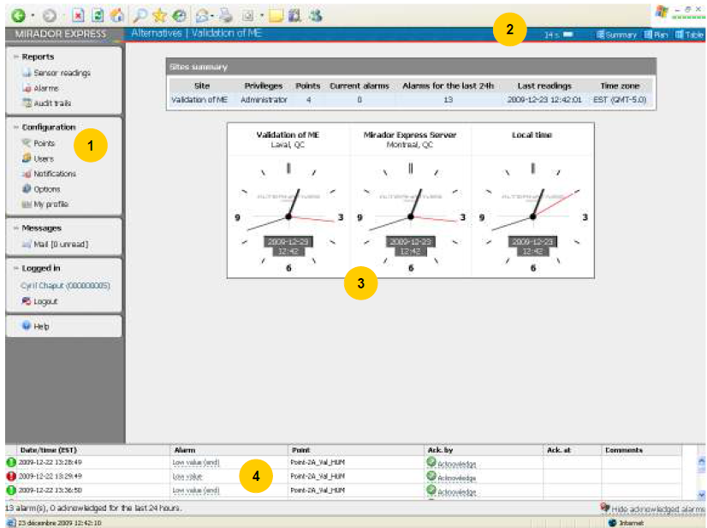

* + 1. The left section (**1**) includes Main menu items grouped in Reports, Configuration, Messages and Logged in blocks. Depending on user privileges at current site, not all of the menu items may be available (see Annex 1 for details). This section also includes information about status of your internal mailbox (refer to Using internal mail chapter) and your login status.
    2. The header section (**2**) displays the name of your company and currently selected site, server poll indicator and the display mode buttons, which toggle the view in the Display section ("Summary", "Plan" or "Table"). In "**Summary**" mode the Display section (**3**) shows the list of all sites in your company, where you have access. For each site, the following details are displayed:
       1. your privilege level for this site
       2. number of data acquisition points
       3. number of current alarm situations
       4. number of all recent alarms
       5. date and time of the last sensor readings
    3. You can change the active site by clicking on its name in the table.

6.3 Alarms

* + 1. The **Alarms** section (**1**) of the Main interface displays the list of recent alarms triggered by the system as well as the alarms status messages (acknowledge information and comments). You can choose to hide already acknowledged alarms by clicking on **Hide acknowledged alarms** (**A**) link located at bottom-right corner of this section. To see all alarms recently triggered by the system, user must click on **Show acknowledged alarms** link. Period for which alarms are displayed in this section can be changed by administrator of the system (refer to Configuration: Options.
    2. The user may also choose to acknowledge alarm by clicking on **Acknowledge** link (in case the alarm has not been acknowledged yet and user has sufficient privileges to do so) or enter a follow-up message by clicking on the **Comments** link for acknowledged alarm.
    3. ***Acknowledgement of alarms:*** You need to have **Alarms Manager** access level or higher to acknowledge alarms.
    4. Click on **Acknowledge** link (**B**) to open **Acknowledge alarm** dialog window (**2**).

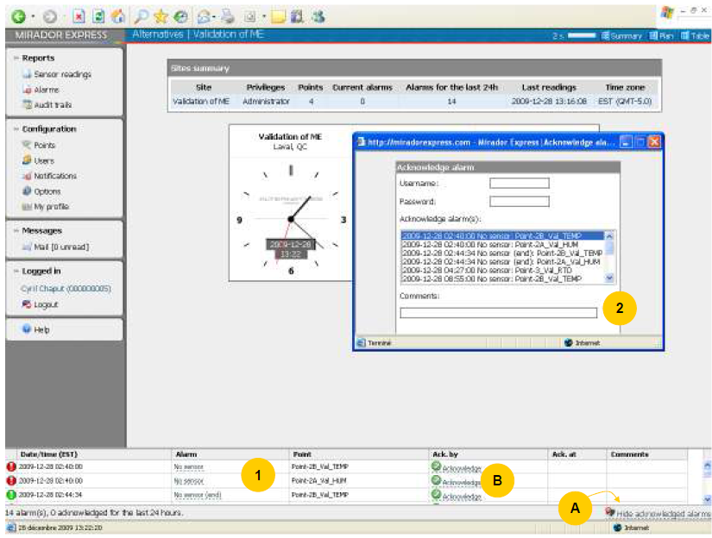

* + 1. In **Acknowledge alarm** dialog window select alarms you want to acknowledge, using the list box.
    2. Press and hold **Ctrl** key to select multiple non-consecutive alarms.
    3. Press and hold **Shift** key or click and drag to select multiple consecutive alarms.
    4. Enter your comments in **Comments** edit box.
    5. In case configuration of your system requires entering login and password to acknowledge alarms, you must enter login and password.
    6. Press **Acknowledge** button to acknowledge selected alarm(s) or on **Cancel** button to close the window and cancel procedure.

6.4 Comments for Acknowledged Alarms

* + 1. **Comments (2)** can be added on already acknowledged alarms. This functionality is used when corrective actions or follow-ups are done after the acknowledgment of an alarm and needs to be recorded.
    2. Select alarm to which you want to add a comment, from either **Alarms** interface or in the bottom section of main interface.
    3. To open **Alarm comments (1)** window with a list of previous comments, click on selected acknowledged alarm comment link (**Comments** column).
    4. In **Alarm comments** window enter your new comment into **Add comment** edit box.
    5. Click on **OK** button to save new comments or on **Cancel** button to close the window and cancel procedure.
    6. Number of added comments made for acknowledged alarm is displayed in **Comments** column.
    7. Click on alarm description in **Alarm** column. **Alarm details** window will appear, showing detailed alarm information, as well as sensor readings (if available) during the time of alarm.

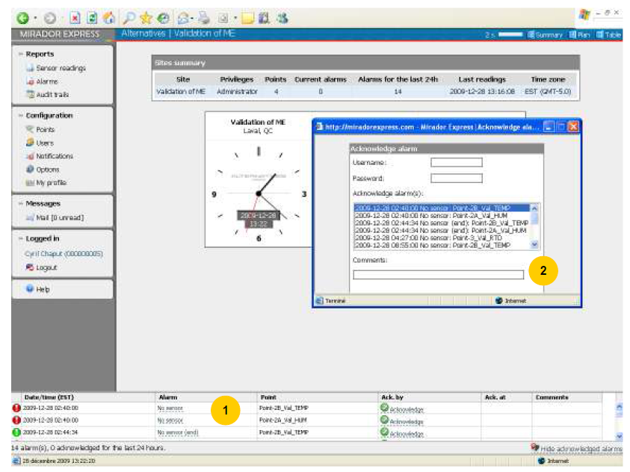

6.5 Header Section

* + 1. On the header section (**1**) are the display mode buttons:
       1. ***Summary:*** the default Display section will appear (**2**). Here in ***Summary*** mode.
       2. ***Plan:*** the Floor plan Display section will appear.
       3. ***Table:*** the Table Display section will appear.

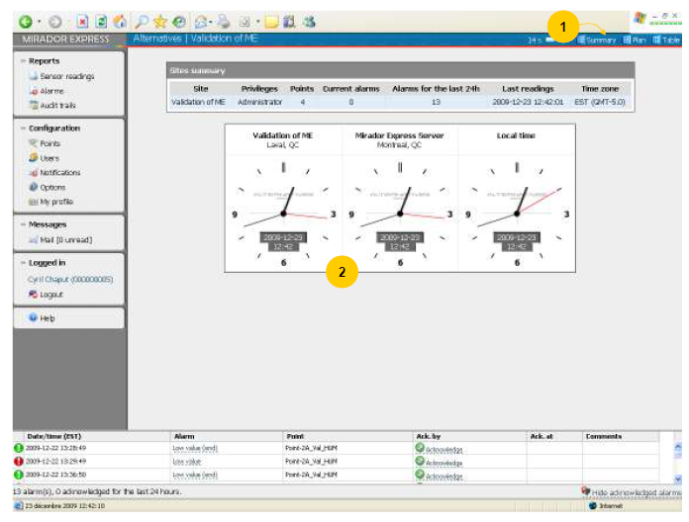

* + 1. On the header section (**1**) are the display mode buttons:
       1. ***Summary:*** the default Display section will appear.
       2. ***Plan:*** the Floor plan Display section will appear.
       3. ***Table:*** the Table Display section will appear (**2**). Here in ***Table*** mode.

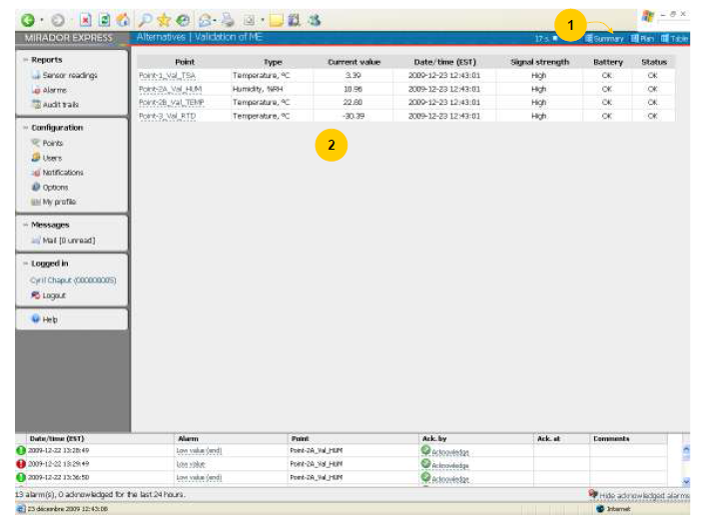

* + 1. On the header section (**1**) are located the display mode buttons:
       1. ***Plan:*** the Floor plan Display section will appear (**2**).
          1. If you have **Administrator** privileges for the current site, you may create or modify the floor plan of this site.
          2. In Main interface, switch to "Plan" display mode. The floor plan of the currently selected site will be displayed. If you don't see a floor plan, it means it's not created yet.
       2. Click the red arrow icon in lower-right corner of the floor plan area to edit the floor plan (3).

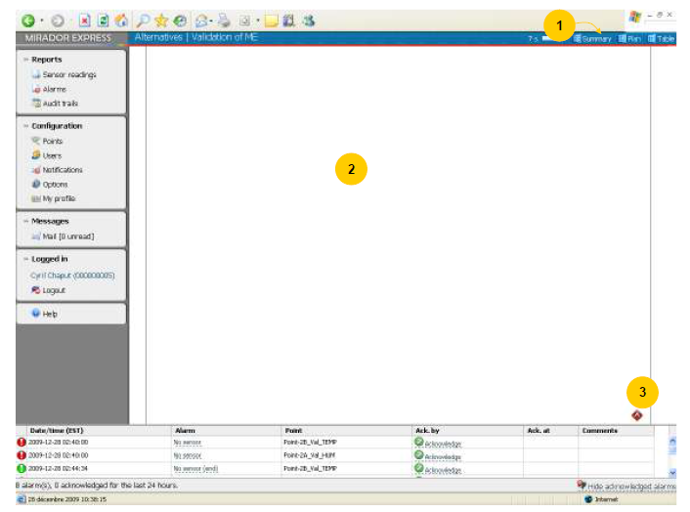

* + 1. ***Plan*** Display mode (**1**):
    2. The editor menu will be displayed (**2**):
    3. The following tools are available:
       1. **Draw**: to draw lines (representing walls and dividers).
       2. **Erase**: to erase lines, objects and points.
       3. **Object**: to put an icon of the object (e.g. freezer) on the plan. Click on the object repeatedly to change icons.
       4. **Point**: to put a point display on the plan. Click on the object repeatedly to change the orientation of the point display. Click on the white arrow on the point display to choose a point.
    4. Click the Save button to save your floor plan. It will be available to all users watching this site.
    5. To discard changes and reload the plan, click the **Reload** button.
    6. Click the red arrow icon (**3**) to close the editor.

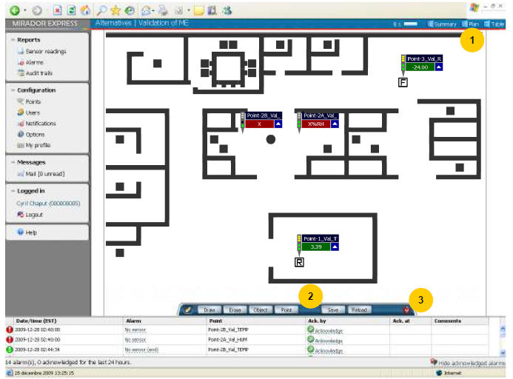

* + 1. Click on **Sensor Readings** in the Main menu (**1**).
    2. **Sensors Readings** (**1**) interface is used for generating reports or graphics based on sensors readings (temperature, humidity, pressure etc.) stored in database. All users with **Report reader** access level or higher can use this interface.
    3. Sensor Readings window (2):
       1. ***Points:*** Select point name(s) to use for building report or graphic. Press and hold **Ctrl** key to select multiple non-consecutive points. Press and hold **Shift** key or click and drag to select multiple consecutive points. For graph and PDF report types you may select up to 5 points. PDF reports are limited to 8 data columns.
       2. ***Show deleted points:*** Select **Show deleted** checkbox if you want to select previously deleted point. Deleted points will be displayed in the list ending with asterisk (**\***).
       3. Units of display:
          1. Select one of these temperature units from drop down list:
* Degree C (Celsius) or Degree F (Fahrenheit) or Degree K (Kelvin)
  + - * 1. Select pressure units from drop down list:
* PSI, Atm., bar, cm WC or in WC
  + - * 1. Select humidity units from drop down list:
* % RH

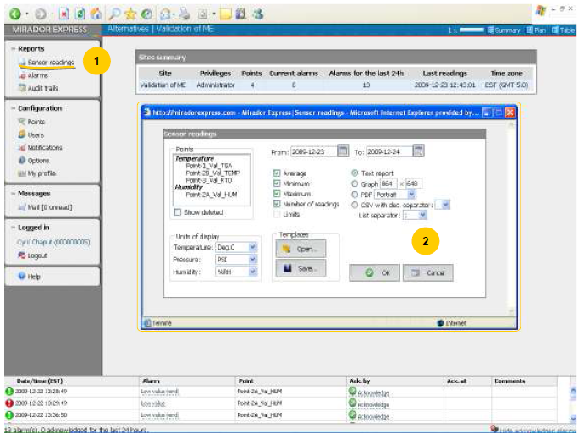

* + 1. From Sensors Readings interface:
       1. Report of Sensor readings (Text Report)

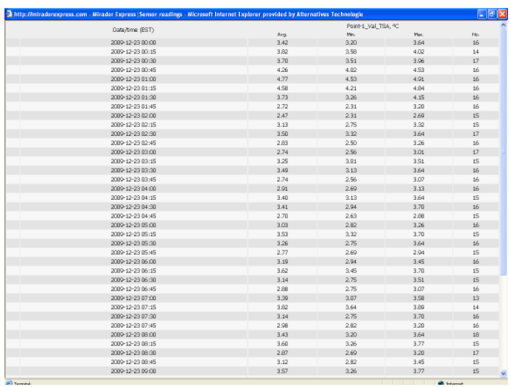

* + 1. From Sensors Readings interface:
       1. Report of Sensor readings (Graph report)

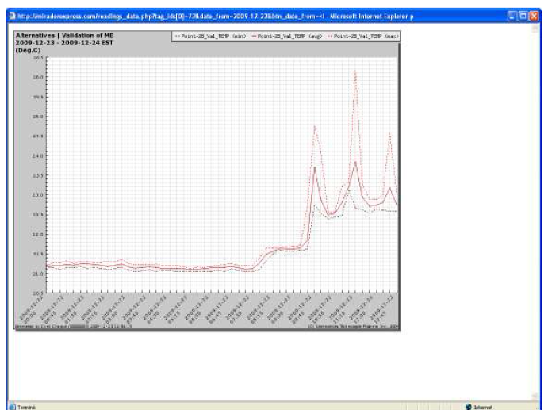

* + 1. From Sensors Readings interface:
       1. Report of Sensor readings (PDF report)

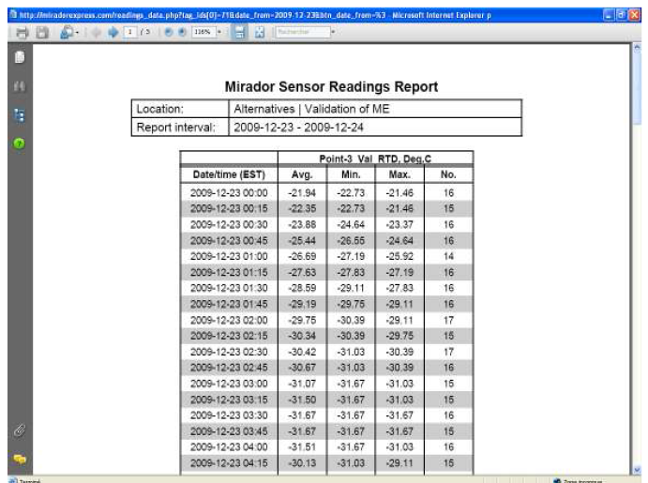

6.6 alarms

6.6.1 Click on **Alarms** on the Main menu (**1**).

* + 1. **Alarms** interface is used for generating reports of alarms conditions (such as **parameter is not within the acceptable limits** or **no sensor**) according to selected options for particular period of time. All users with **Report reader** access level or higher can use this interface.
    2. ***Alarms*** window: (**2**)
       1. ***Sensor points:*** Select point name(s) to be use for building report. Press and hold **Ctrl** key to select multiple non-consecutive points. Press and hold **Shift** key or click and drag to select multiple consecutive points.
       2. ***Type of alarms:*** Select ***Types of alarms*** you want to include into report by checking corresponding checkboxes. Available types:
          1. No sensor
          2. High value and Low value
          3. High-high value and Low-low value
          4. ***Types of reports:*** Select report format you want to create. Available formats:

Text/HTML or PDF (additionally you can select the paper orientation).

***Selection*** ***of the reporting period of time***: Select dates ***From*** and ***To*** as reporting period (current day by default). To change dates ***From*** and ***To*** click on calendar button located at the right of the date edit box. Select date and time using calendar dialog.

It is possible to enter date and time into edit box manually. Use yyyy-mm-dd as date format and hh:mm as time format separated by space, e.g. 2006-05-25 18:45.

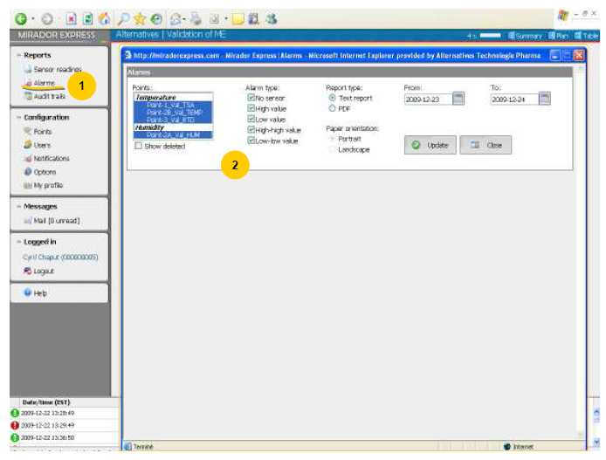

6.7 Audit trails

* + 1. Click on **Audit trails** on the Main menu (**1**).
    2. **Audit trails** interface is used to display audit trails recorded by ***Mirador™*** system. Only users with **Administrator** access level may use this interface.
    3. Audit trails window (2):
       1. ***Selection of the reporting period of time:*** Select dates **From** and **To** as reporting period (current day by default). To change dates **From** and **To** click on **calendar** button located at the right of the date edit box.
       2. Select date and time using calendar dialog. It is possible to enter date and time into edit box manually. Use **yyyy-mm-dd** as date format and **hh:mm** as time format separated by space, e.g. 2006-05-25 18:45.
       3. ***Type of audit records:*** Select type of audit records you want to display. Available audit records types: All, System, Configuration.
       4. ***Site:*** Select a site where you have Administrator privileges or "All" to show events for all sites. Note: some event types don't belong to any site and are always displayed.
       5. ***User:*** In **User** dropdown list select the name of the user (if you want to see records related to one particular user) or select **All** if you want to include records for all users.
       6. ***Show deleted users:*** Check **Show deleted users** checkbox to include names of the **User** dropdown box names of the users which were previously deleted into the **User** dropdown box. These names will be displayed ending with an asterisk symbol (**\***).
       7. ***Generating of report:*** Click on **View** button in **Trails** window to generate report according to selected options and parameters. Click on **Close** button in **Trails** window to close this window. All selected options will be discarded.

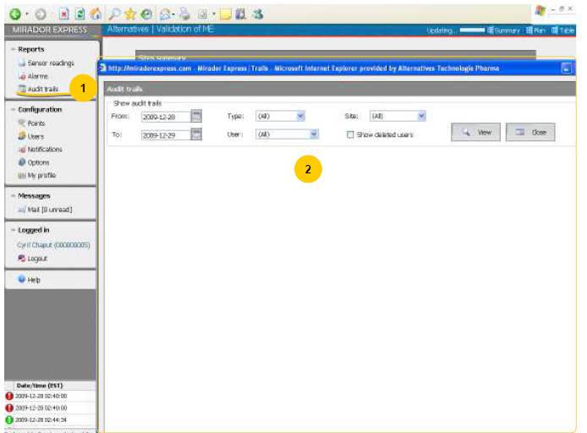

6.8 points

* + 1. Click on Points on the Main menu (1).
    2. Configuration: Points interface is used for configuration and setup of parameters (such as label or limits) for monitored equipment or locations. Only users with **Administrator** access level may use this interface.
    3. ***Points*** window (**2**):  
       To edit parameters of a point, click on **Edit point** button to the right of the point (**A**). **Edit point** dialog window will pop-up (**3**). Fill out the following edit boxes:
       1. Point Name (This name is used as link between real-time data and floor plan).
       2. Description (Optional)
       3. High-High limit / High limit
       4. Low limit / Low-Low limit
       5. Limits alarm delay (delay before triggering an alarm when high, high-high, low or low-low limits reached)
       6. Select type of the sensor in **Point type** dropdown list. Following types are available:
       7. Unknown (Used by default for new point. A valid sensor type must be selected here).
       8. Temperature
       9. Pressure
       10. Humidity

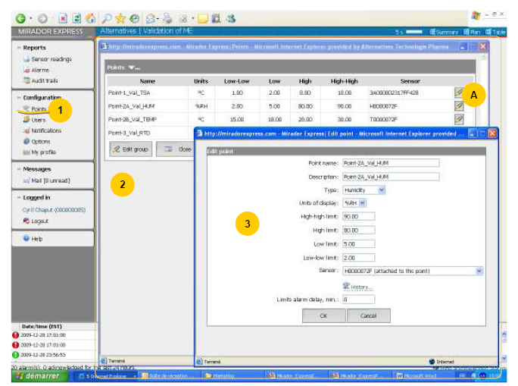

* + 1. **Configuration: Points** interface is used for configuration and setup of parameters (such as label or limits) for monitored equipment or locations.
    2. Select **Units of display** for sensor in **Units of display** dropdown box. Following units are available (depending on point type):
       1. Degree C (Celsius)
       2. Degree F (Fahrenheit)
       3. Degree K (Kelvin)
       4. PSI
       5. Atm
       6. Bar
       7. cm WC
       8. in WC
       9. % RH
    3. Select the sensor attached to this point in **Sensor** combo-box. You may click on **History...** link to view sensor connections & disconnections history for this point.
    4. Click on **OK** button to save changes or on **Cancel** button to close window and cancel all changes. A group of points can be edited at the same time using **Edit group** button (**A**). All information you will provide in edit boxes will be updated in all selected points. No update will be made if an edit box is left blank.

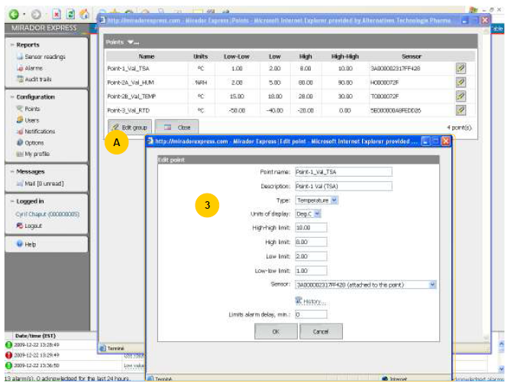

6.9 users

* + 1. Click on **Users** in the Main menu (**1**).
    2. **Configuration: Users** interface is used to manage user accounts of persons who qualify to access **ATP*Mirador* ™ *Express***.
    3. ***Users*** window (**2**):

Only users with **Administrator** access level may use this interface. The following information about accounts is displayed:

* + - 1. Username (login of the user)
      2. First and last name of the person
      3. Employee number
      4. Account status (active/disabled)
      5. ***Add user account*** (**3**)

Click on **Add user** button located at the bottom of the list of users. **Add user account** window will pop-up.

Fill out appropriate information into the following edit boxes:

* + - 1. Username (login of the user; may contain only letters, digits, dots and underscores)
      2. Employee number
      3. First name
      4. Last name
      5. Password
      6. Confirm password
      7. E-mail address (optional)

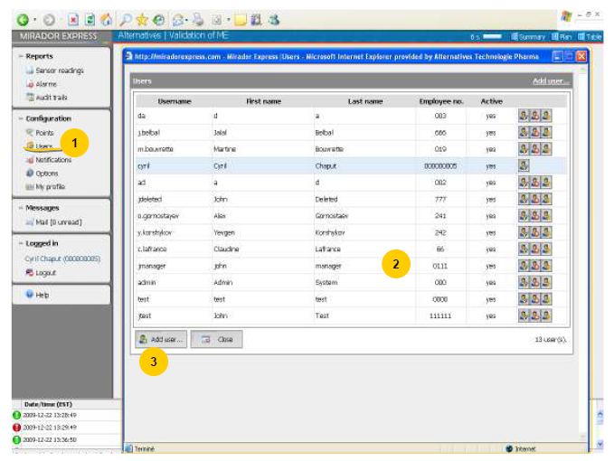

* + 1. By default, value for **Password expires** edit box is equal to Password expiration interval, according to current system parameters. You can change **Password expires** date by clicking on **calendar** button located to the right of edit box and selecting the date in popup calendar.

NOTE: You can enter date and time into the edit box manually. Use **yyyy-mm-dd** as date format and **hh:mm** as time format separated by space.

* + 1. Other available parameters of user account are: Active: Yes / No. Used to temporary block an account.
    2. After the password expires, the account can be unblocked by: User / Administrator only.
    3. Click on **OK** button to save entered information and add a new user or on **Cancel** button to cancel changes.
       1. ***Edit user account:*** Click on **Edit** button located in the right column of the selected user to edit user account (**1**). **Edit user account** dialog window will pop-up (**2**).
       2. Edit information in corresponding edit boxes or change states of radio buttons. Some fields cannot be modified. Click on **OK** button to save changes or on **Cancel** button to close window and cancel all changes.
       3. ***Delete user account:*** Click on **Delete user account** button (**3**) located in the right column of the selected user. Confirmation pop-up window will be displayed. Click on **OK** button to confirm deletion or on **Cancel** button to cancel.
       4. ***Change user access level:*** Click on **Change access level** button (**4**) located in the right column of the selected user. **Change user access level** dialog window will pop-up. The dialog will list the sites where you have Administrator privileges and user's access level at these sites.

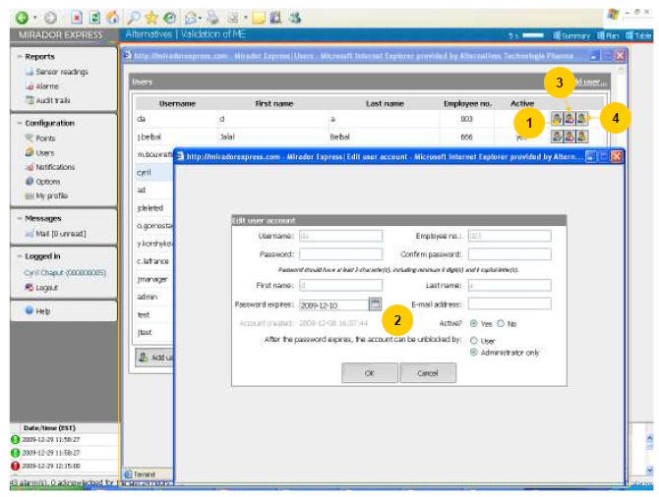

6.10 Notifications

* + 1. Click on **Notifications** on the Main menu (**1**).
    2. Configuration: Notifications interface is used for management of alarms recipients and alarm notifications schedules. Only users with **Administrator** access level may use this interface.
    3. Notifications window (2):
       1. The following information about recipients can be found in the recipients table:
          1. Name
          2. Address (mail address for cell, pager or e-mail)
          3. Active (recipient status: active/disabled)
       2. The following information about schedules can be found in the schedules table:
          1. Name
          2. Delay, min. (latency time before activating the alarm schedule)
          3. Recipients (list of recipients that will receive the alarm message at the same time)
          4. Day and time (time range in which the recipients of an alarm will receive an alarm message if an alarm is triggered)
          5. Active (schedule status: active/disabled)
          6. You can toggle between Tables and Graph mode of display using the **Graph mode** / **Table mode** link in upper-right corner of the window.

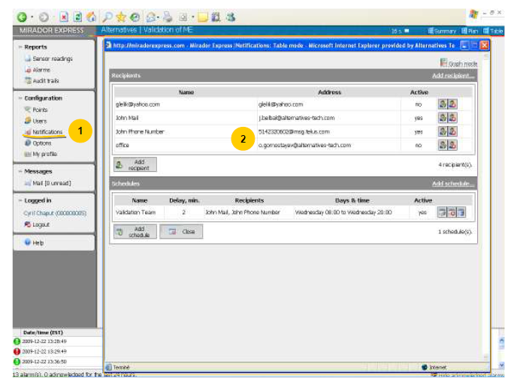

6.11 Adding recipients

* + 1. Click on **Add recipient** button located at the bottom of the list of recipients. **Add recipient** dialog window will pop-up (**2**). Fill out the following edit boxes: Name (name of recipient), E-mail address.
    2. To select the right e-mail address format for your cell phone or pager provider, you can use the list of international service providers. Click on **Service providers…** button and select your paging or phone service provider and click on **OK** button. To cancel operation, click on **Cancel** button.
    3. Template of e-mail address to reach your pager or cell phone will be copied into the **E-mail address** edit box. Substitute the left part of the template with given information (e.g. replace **10_Digits_Phone** string to actual phone number or **PIN_number** by your actual PIN number etc.). The only purpose of this tool is to help you in this task and is not intended to replace your service provider instructions.
    4. Select messages format from dropdown list: Simple text (recommended for pagers and cell phones), HTML (recommended for e-mail recipients).
    5. Check **Active** checkbox to set recipient address as active.
    6. If **Send 'Back to normal' alarms** checkbox is checked, the recipient will receive a notification when a parameter returns back to normal value.
    7. 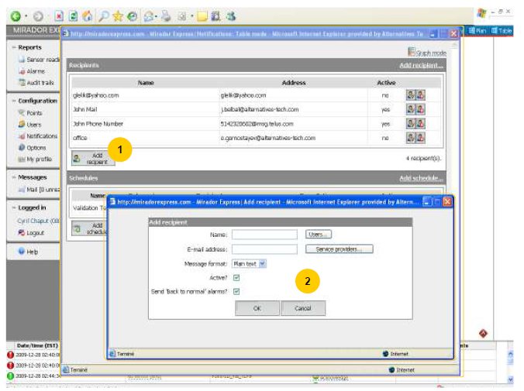Click on **OK** button to save changes or on **Cancel** button to cancel all changes.
    8. Edit recipient (1):
    9. Click on **Edit** button located in the right column of the selected recipient to edit recipient information. **Edit recipient** dialog window will pop-up.
    10. Edit information in corresponding edit boxes, dropdown list or change states check boxes.
    11. Click on **OK** button to save changes or on **Cancel** button to close window and cancel all changes.
    12. Delete recipient (2):
        1. Click on **Delete recipient** button in the right column of the selected recipient. Confirmation pop-up window will be displayed.
        2. Click on **OK** button to confirm deletion or on **Cancel** button to cancel.
        3. Click on **Close** button located at the top of the configuration dialog window to close configuration page and return to main interface.

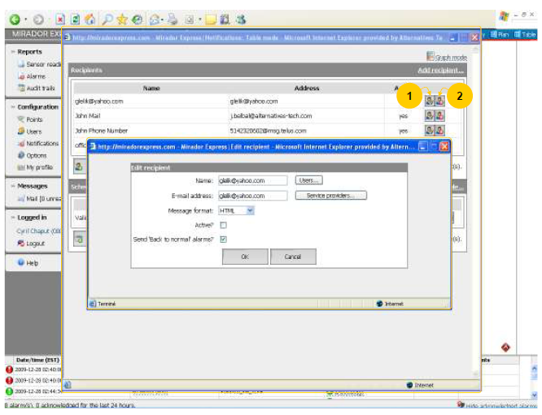

6.12 Add schedule

* + 1. Click on **Add schedule** button located at the bottom of the list of recipients. **Add recipient** dialog window will pop-up.
    2. Fill out the following edit boxes (**2**):
       1. Name
       2. Delay, min. (message will be send after this delay if the alarm is not acknowledged during this delay).
       3. Interval of time: **From… To…** where you want this schedule do apply (click on **All day** button if you want to include all day). Note that the time format in ***Mirador*™ *Express*** is: (23:59).
       4. Select **weekday(s)** where schedule will be active using **Day of the week** dropdown list. The following options are available: (Any day), Monday, Thursday, Wednesday, Thursday, Friday, Saturday, Sunday, (Weekdays), (Weekend).
       5. Select **Alarm type** in **Alarm type** dropdown list. The following options are available:
          1. All
          2. High
          3. Low
          4. High-High
          5. Low-Low
          6. No sensor

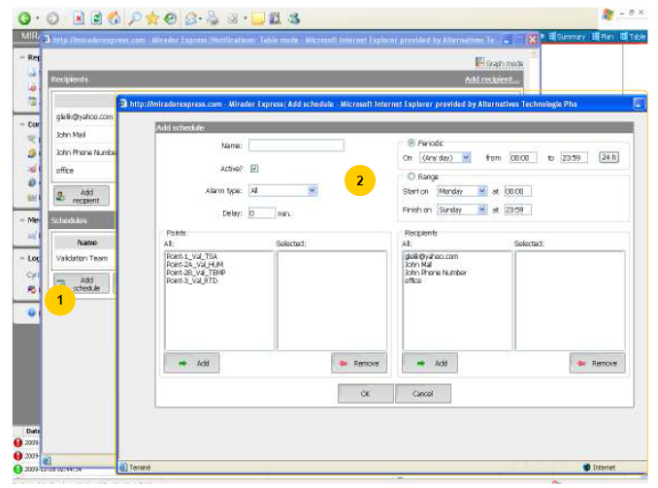

* + 1. Select points you want to include in this schedule from the **Points** list (**1**).
    2. Press and hold **Ctrl** key to select multiple non-consecutive points. Press and hold **Shift** key or click and drag to select multiple consecutive points
    3. Click on **Add** button located under **Points** list box to add selected points to **Selected points** list box.
    4. Click on **Remove** button located under **Selected points** list box to remove points from **Selected points** list box.
    5. Select recipient names you want to include in this schedule from **Selected** points list box (**2**).
    6. Press and hold **Ctrl** key to select multiple non-consecutive recipients. Press and hold **Shift** key or click and drag to select multiple consecutive recipients.
    7. Click on **Add** button located under list of all recipients to add selected recipients to **Selected** recipient list box.
    8. Click **Remove** button located under **Selected** list box could be used to remove points from **Selected**.
    9. Click on **OK** button to save changes or **Cancel** button to close window and cancel all changes.

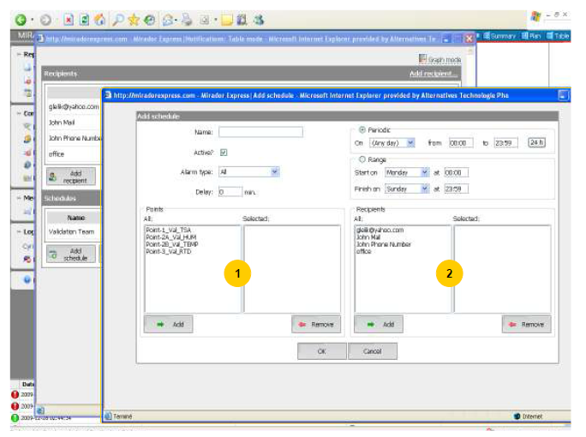

6.13 Edit schedule

* + 1. Edit schedule (1).
    2. Click on **Edit** button located in the right column of the selected schedules to edit schedule information. **Edit schedule** dialog window will pop-up.
    3. Edit information in corresponding edit boxes, dropdown list or change state of check boxes.
    4. Click on **OK** button to save changes or on **Cancel** button to close window and cancel all changes.
    5. ***Delete schedule*** (**2**)
       1. Click on **Delete recipient** button located in the right column of the selected schedules. **Confirmation** popup window will be displayed.
       2. Click on **OK** button to confirm deletion or on **Cancel** button to cancel.
       3. Click on **Close** button located at the top of the configuration dialog window to close configuration page and return to main interface.

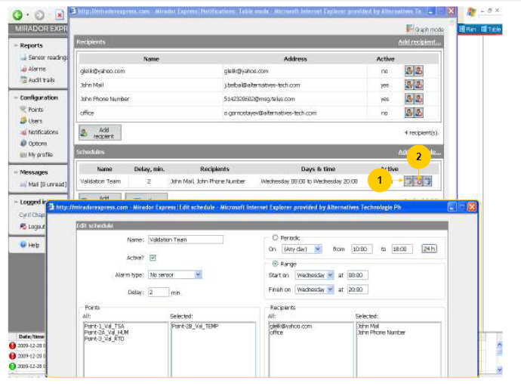

6.14 Options

6.14.1 Click on **Options** on the Main menu (**1**).

* + 1. **Configuration: Options** interface is used to define and edit various site parameters. They apply for the currently selected site only. Only users with **Administrator** access may use this interface.
    2. The following parameters can be edited (**2**):
       1. **Password expiration interval, days:** N days after account creation or password re-initialization, the password will expire and will have to be recreated in accordance with password policies. Default value: 30.
       2. **Password reutilisation interval, days:** Passwords created in ***Mirador*™ *Express*** cannot be reused before the completion of this interval. Default value: 60.
       3. **Session timeout, seconds:** Interval of user's inactivity, after which the login session expires. Default value: 600.
       4. **Server poll interval, seconds:** Elapse time between server interrogations about new events (readings, alarms, e-mail, etc.). Default value: 10.
       5. **Ask password on acknowledge of alarms: Yes / No:** If you want to force the user to identify himself when acknowledging alarms. Default value: No.
       6. **Display alarms for the last NN hours:** Time interval that you want alarms to be displayed on the main interface. Default value: 24.
       7. **Reading’s invalidation interval, sec.:** Delay between your disconnection from the server and the time all readings displayed on the main interface will be erased and replaced by “X”, meaning you are disconnected. Default value: 60.
       8. **Minimum password length:** Minimum amount of characters in a password. Default value: 5
       9. **Minimum amount of number in a password:** Default value: 0.
       10. **Minimum amount of capital letters in a password:** Default value: 0.

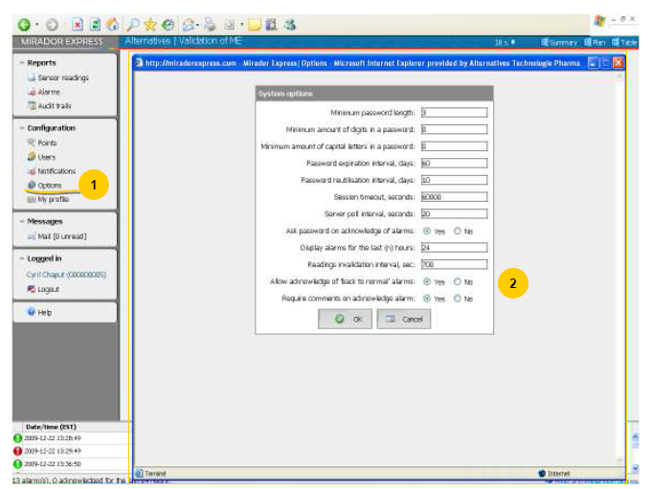

6.15 My Profile

* + 1. Click on **My Profile** on the Main menu (**1**).
    2. **My profile** interface is used for modifying user interface options, specific to current user. All users have access to **My profile** interface (**2**). All changes made into **My profile** interface will affect only the account of current user and do not have any effect on other accounts or interfaces.
    3. Preferred language
       1. Select your preferred language of user interface in **Preferred language** dropdown list. Available user interface languages: English, French.
    4. Style of the user interface
       1. You can select the style of user interface using **Pages style** dropdown list. Available page styles: Default (standard font size), Smaller text (small font size).
       2. Click on **OK** button to apply changes or on **Cancel** button to cancel.
    5. Password
       1. Click on **Password** button to change your password. **Change password** dialog window will pop-up.
       2. Fill out following edit boxes in **Change password** dialog window: Old password (your current password),
    6. New password, Re-enter new password.
       1. Click on **OK** button to apply changes or on **Cancel** button to cancel.
       2. **Mail** interface allows a user of the system to communicate with other users. You can send text messages to one or multiple users, receive messages sent to you, reply to them or forward them to other user(s).
       3. Additionally, it is used to notify user about system events, such as equipment maintenance, etc.
       4. All users may access **Mail** interface.
       5. Click on **Mail** on the Main menu (**1**).

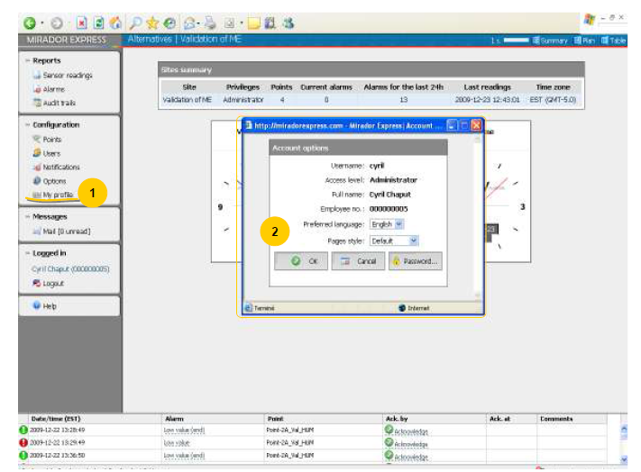

6.16 mail

* + 1. **Mail** interface (**1**):
       1. Send mail message
          1. In **Mail** window click on **New…** button to open **Send message** window. Select user name in dropdown list and click on **<< Add user** button located at the left of dropdown list.
          2. Repeat previous step to select other users if the message should be sent to multiple recipients.
          3. Enter subject of the message in **Subject** edit box. Select message priority in **Priority** dropdown list. Enter message text in **Message** edit area. Click on **Send** button to send message or **Cancel** to close window without sending.
       2. Selecting/deselecting messages
          1. In messages list, you can select multiple messages for future operations on selected messages.
          2. Messages can be selected or deselected by checking/unchecking corresponding checkboxes located at the left column of the list. To select or deselect all messages click on **Check** or **Uncheck** buttons located at the bottom of the list.
       3. Delete selected messages
          1. To delete selected messages, click on **Delete** button located at the bottom of the **Messages** list.

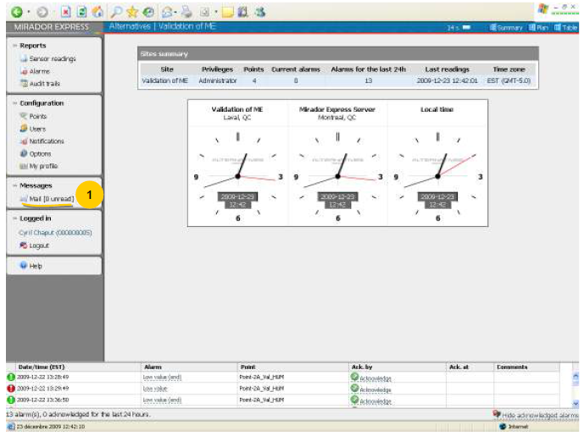

* + 1. **Mail** interface (**1**):
       1. Read message
          1. Click on subject link of selected message you want to read to see its content in the messages content area.
       2. Reply/forward message
          1. Click on subject link of selected message you want to reply or forward. Click on Reply or Forward button located below the message text. (Reply button is disabled for messages received from system.)
       3. Modify message attributes as described in New Mail section, and enter other text if necessary. Click on Send button to send message or on Cancel button to close window without sending.
       4. Delete current message
          1. Click on Delete button located at the bottom of message content. Confirmation dialog will pop-up.
          2. Click on OK button to confirm deletion or on Cancel button to cancel.
          3. Click on Close button to return to main interface.

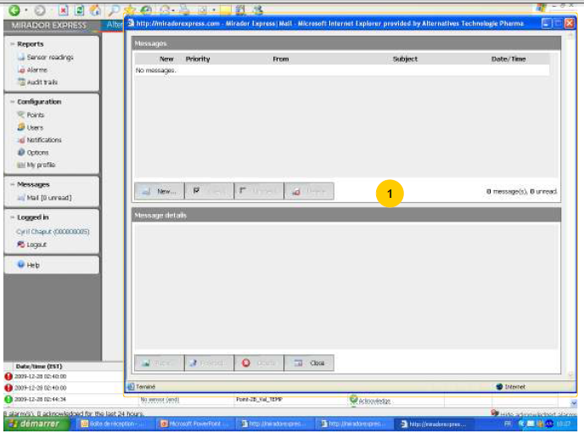

* + 1. As long as you are logged in, your full name and employee number is displayed in Logged in section of the main menu (1).
       1. To end Mirador™ Express session or to login as another user, click on Logout button (2). Confirmation dialog will pop-up (3).
       2. Click on OK button to confirm logout or Cancel button to cancel.
    2. When user's login session expires, the message "Session expired" is shown in **Logged in** section of the main menu. To continue working with ***Mirador*™ *Express***, click **Logout** and login again.

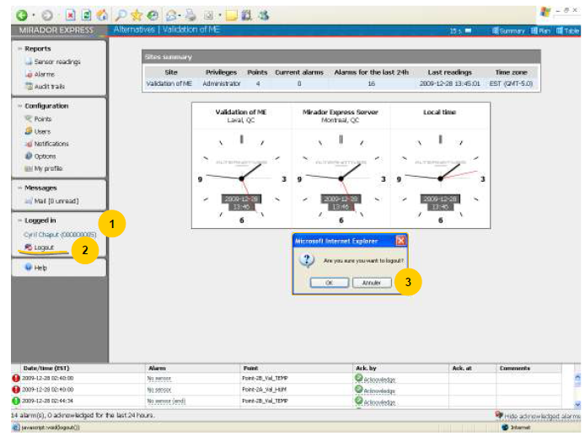

6.17 help

6.17.1 On the main interface, to access the **Help** section of the ***Mirador*™ *Express***, click on the **Help** on the Main menu (1).

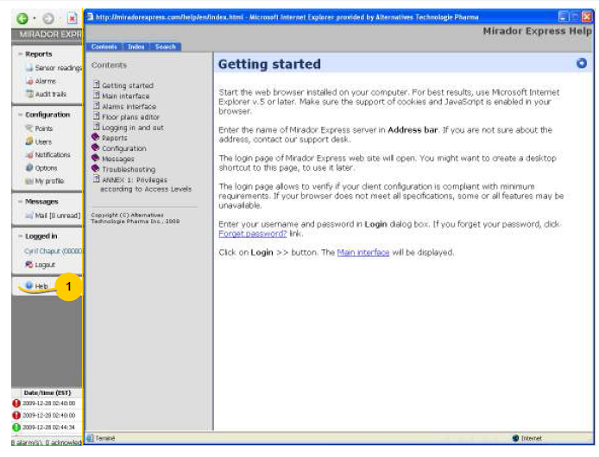

6.17.2 Access rights to interfaces depending on access levels:

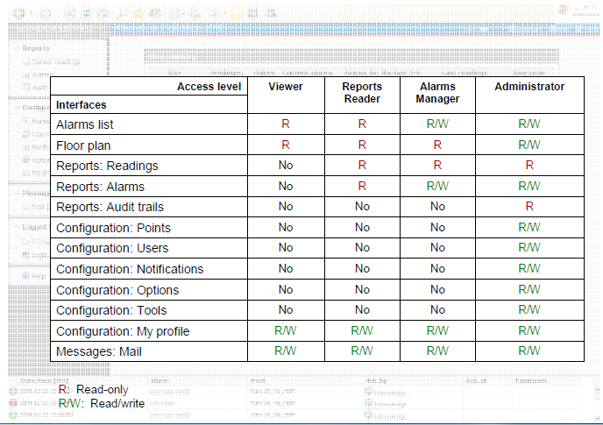

6.19 Summary

* + 1. If you want:
       1. to access help content of ***Mirador*™ *Express*** services: click on **Help** button in the Main menu (left).
       2. to change your profile: click on **My profile** in the **Configuration** group of the Main menu left).
       3. to have the table display: click on **Table** button in the header menu (top right).
       4. to have the plan display (if available): click on **Plan** button in the header menu (top right).
       5. to see alarms: go to the **Alarm** display section to see the alarms in the last 24 hours (bottom).
       6. to acknowledge/comment alarms: go to the **Alarm** display section (bottom) and click on **Acknowledge** icon of the selected alarms.
       7. to have a report on readings: click on **Sensor readings** in the **Reports** group of the Main menu (left).
       8. to have a report on alarms: click on **Alarms** in the **Reports** group of the Main menu (left).
       9. to have an Audit trails report: click on **Audit trails** in the **Reports** group of the Main menu (left).
       10. to add, modify or delete reading points: click on **Points** in the **Configuration** group of the Main menu (left).
       11. to add, modify or delete users: click on **Users** in the **Configuration** group of the Main menu (left). Also, to change access rights of users.
       12. to add, modify or delete users: click on **Users** in the **Configuration** group of the Main menu (left). Also, to change access rights of users
       13. to configurate alarms and alarm notifications: click on **Notifications** in the **Configuration** group of the Main menu (left).
       14. to change system parameters: click on **Options** in the **Configuration** group of the Main menu (left).

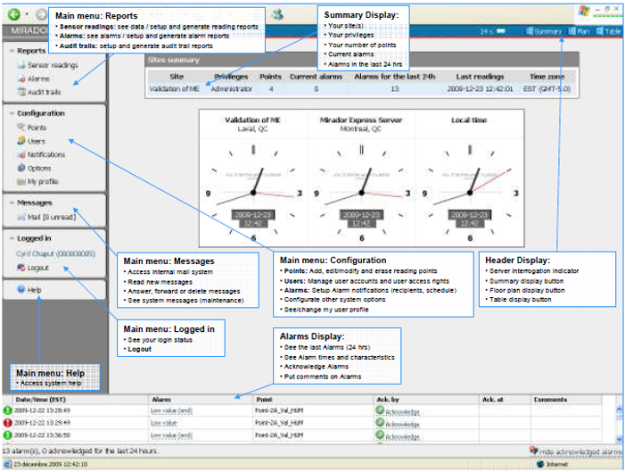

# 7.0 references

# 8.0 revision history

|  |  |  |
| --- | --- | --- |
| **Revision #** | **Revision Date** | **Description** |
|  |  |  |